

What is LEGO Therapy and How Does it Transform Lives?
LEGO® therapy has emerged as a groundbreaking intervention that transforms colourful plastic bricks into powerful tools for developing social skills, communication abilities, and emotional regulation. This evidence-based approach has gained significant recognition among therapists, teachers, and parents worldwide for its effectiveness in helping autistic children and those with other social communication challenges.

The Foundation of LEGO Therapy: History and Development
Dr. Daniel LeGoff, a clinical neuropsychologist in Philadelphia, pioneered LEGO therapy in the early 2000s after making a remarkable observation: children with autism who struggled in traditional social settings often displayed increased engagement and communication when collaborating on LEGO projects. This serendipitous discovery led to the development of a structured therapeutic approach that harnesses children’s natural interest in LEGO building to develop crucial social competencies.

In his groundbreaking 2004 study published in the Journal of Autism and Developmental Disorders, LeGoff documented significant improvements in social interaction among participants in LEGO-based social skills groups. This research laid the cornerstone for what would become a widely adopted therapeutic methodology.

How LEGO Therapy Works: The Building Blocks of Success

The Three-Role Model
LEGO therapy differs from unstructured play because its deliberate framework is designed to promote social interaction. In a standard LEGO therapy session, participants work in groups of three, with each member assuming a specific role:
- Engineer – Holds the building instructions and communicates directions clearly to the team
- Supplier – Locates and provides the specific LEGO pieces needed for each step
- Builder – Assembles the model according to the Engineer’s instructions

This division of responsibilities creates natural opportunities for communication, collaboration, and problem-solving. As sessions progress, participants rotate roles, ensuring they develop skills across different social domains.
Further reading:

LEGO® Therapy: Building Social Skills Brick by Brick
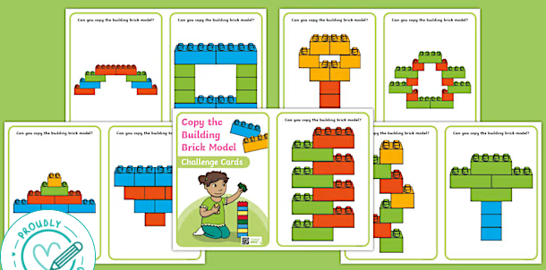
Ideas for brick designs:
Copy the Building Brick Model Challenge Cards

